LOW POWER TRANSMISSION USING LORA TECHNOLOGY

TEAM MEMBERS : E.G.PRADEEP (RA2211004050026) B.PRASANTH (RA2211004050008)



Guided by, DR.M.MATHAN KUMAR DEP OF ECE

ABSTRACT

New technologies have emerged which enable power efficient communication over very long distances. Examples of such Low-Power Wide-Area Network (LPWAN) technologies.A typical application scenario for these technologies is city where devices send readings at very low frequency over a long distance to a data concentrator (one-hop networks).LoRa (Long Range) is a technique that enables the long-range transfer of information with a low transfer rate. This paper presents a review of the challenges and the obstacles of Interference concept with emphasis on the LoRa technology. Along with that the demand for low-power and long-range, large amount of data transmission arises. However, there has been no such communication technology to satisfy the transmission. The Wi-Fi is able to send large amounts of data but because of high power consumption, it has to use firm power. The LoRa technology is available for long-range and low-power communication.

**Key Words : LPWAN,LoRa,Long-range,data,Long distance,Communication.**

INTRODUCTION

**A LoRaWAN network (Long Range Network Protocol) is of the Low Power Wide Area Network (LPWAN) type and encompasses battery powered devices that ensure bidirectional communication. The main contribution of the project is the evaluation of the LoRa technology considering the requirements of Low powered Communication.**

BLOCK DIAGRAM

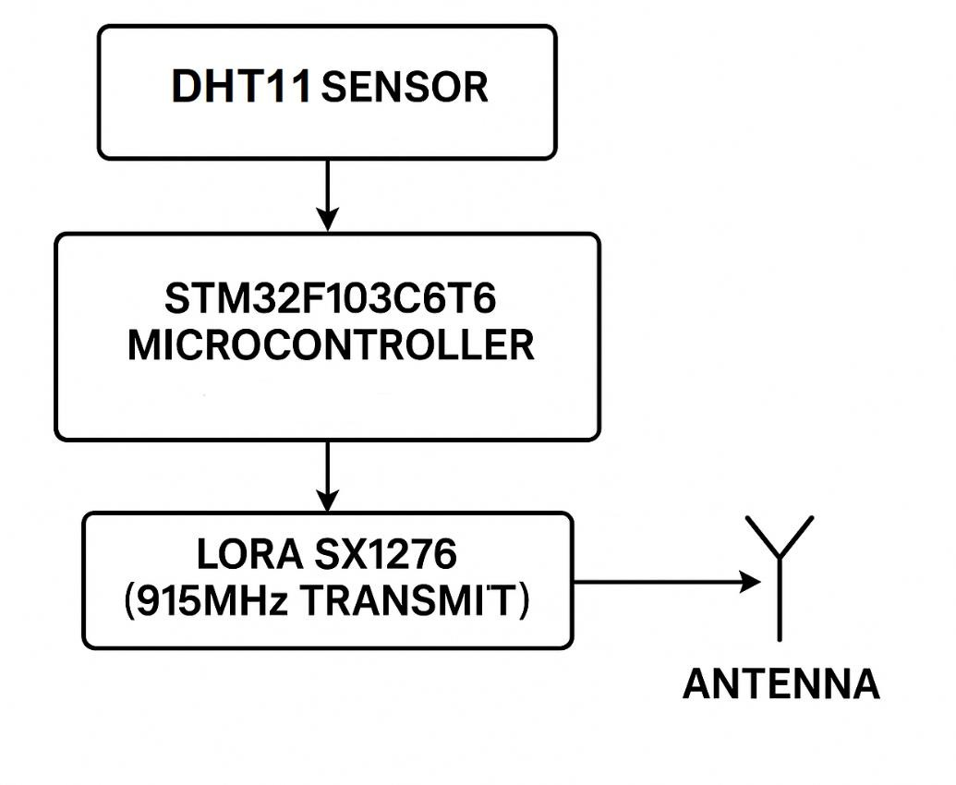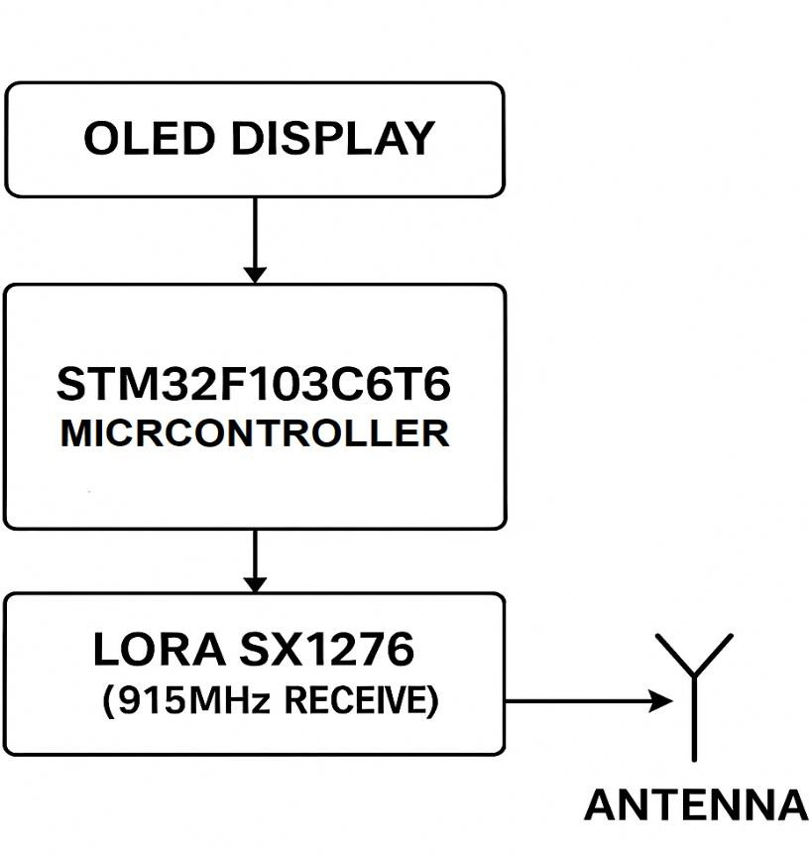

ALGORITHM

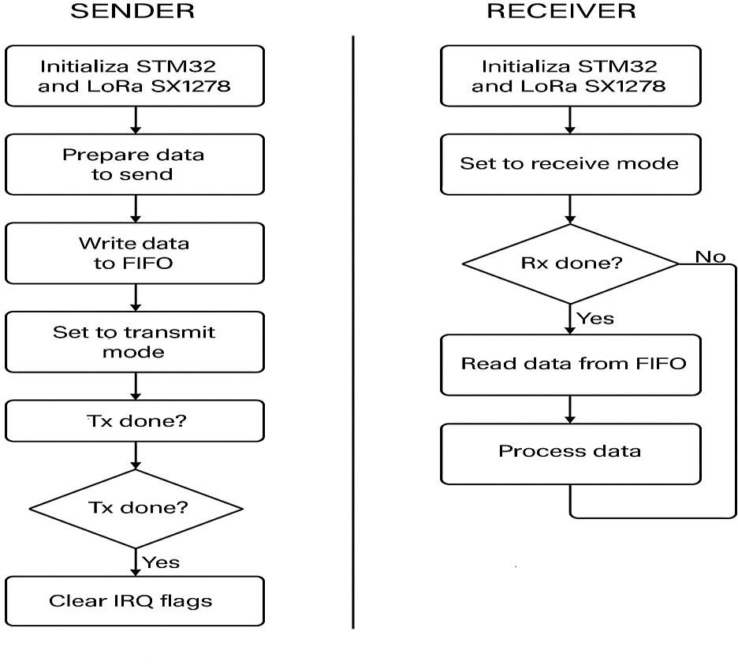

PROTOTYPE HARDWARE

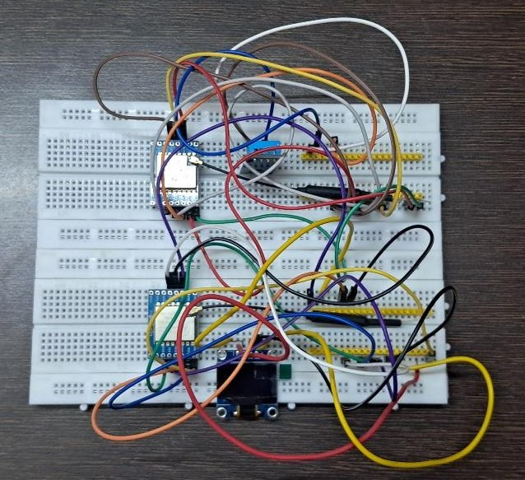



THANK YOU !